(Approx. 989 words)

Where to Get E-Books
By Tom Burt, Vice President, Sun City Summerlin Computer Club
https://www.scscc.club
tomburt89134 (at) cox.net

A perennial challenge is to find suitable gifts for friends and family. Books have always been a popular choice. Now, with the maturing of the electronic book (e-book) format and industry, it should be easier than ever to find just the right title, purchase it and email a link for your giftee to use to access and read the book. Of course, things aren’t so simple in practice, so you may want to read on.

This article is based on a seminar I gave in December 2020 titled “E-Books and E-Readers.” My seminar slides are at: https://www.scscc.club/smnr/E-Books_and_E-Readers_Seminar.pdf .

E-book formats

There are two main formats: Amazon Kindle and E-Pub. There are hardware and software readers for each. Both formats support digital rights management (copy protection) so that the purchaser of a book can’t share it with more than a few others. Amazon mainly uses the Kindle format. E-Pub is used by Barnes and Noble and Kobo and for many self-published books. Adobe PDF and HTML are also often used for e-books. Apple’s iBook format is a variation of E-Pub.

When buying an e-book, it’s important to know what format it is in so you can be sure your reader device or program can read the book. A common problem for owners of Amazon’s Kindle or Fire tablets is that they do not support the E-Pub format. The Amazon app store does not offer an E-Pub reader app. It’s possible to “jailbreak” a Kindle or Fire tablet so that it can install Android apps from the Google play store, including Adobe’s Digital Editions E-Pub reader. But that’s a topic for another day.

E-Book Websites

Here’s a list of e-book websites with links to each:

- Amazon Kindle Store www.amazon.com

- Barnes & Noble http://www.barnesandnoble.com

- Google Play Store Books https://play.google.com/store/books

- Kobo www.kobo.com

- Las Vegas / Clark County Library (via OverDrive) http://lvccld.org

- Open Library https://openlibrary.org/

- Project Gutenberg (60,000 free ebooks) https://www.gutenberg.org/

Let’s look at a few of them in more depth.

Amazon Kindle

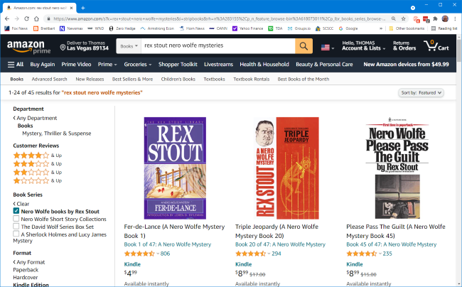

The Amazon bookstore is vast. You can buy books in hardcover, paperback, audio, and e-book format. As with all Amazon shopping, the search is very smart, and you can set filters to narrow choices. In addition, you can click on items in the search results to view details and, from there, add them to your shopping cart.

If buying for yourself, E-books are delivered (downloaded) to the reading device you specify. You can also specify you are buying for someone else and enter the giftee’s information so they can receive the book.

You need an Amazon Kindle or Fire Reader tablet or Amazon’s free Kindle Reader app to read Kindle books. There are versions for Windows, macOS, Linux, Android, and iOS.

If you subscribe to Amazon Prime, you have access to an extensive collection of e-books at no charge via the Prime Reading service. In addition, you can have free access to up to ten e-books for as long as you wish. Then, return or buy one of the ten you have when you want another.

The Amazon Fire HD 10 tablet with 32 GB of storage lists for $100.

Barnes and Noble

Barnes and Noble sells books in “Nook book” (E-Pub) format and paperback and hardcover. B&N also sells a family of Nook reader tablets and has a free reader app. In addition, you can set up an account on B&N and enjoy special pricing, free e-books, and other perks.

See the screenshot below to get a sense of their online store. The search window is very smart.

The Nook book reader is a 10-inch Android tablet (made by Lenovo) with 32 GB of storage, listing at $130. It has full access to the Google Play Store apps. This would include the free Amazon Kindle Reader app for Android. So, a Nook reader tablet could double as a Kindle Reader, allowing you to shop for books in either Nook or Kindle format.

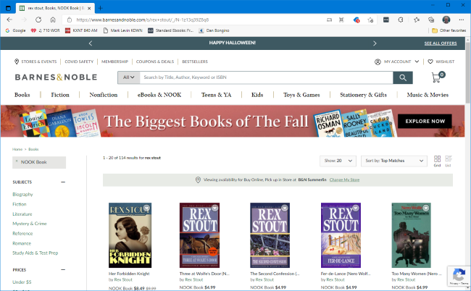

Project Gutenberg

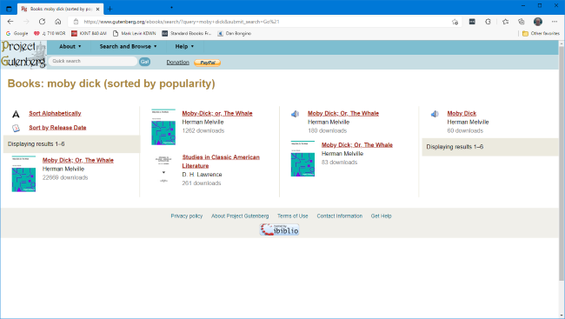

Project Gutenberg was founded by Michael Hart, who invented e-books in 1971. Its website claims to have 60,000 titles in its library. All these titles are completely free. Most are “classics” that are out of copyright. For example, I searched for Albert Einstein and found an English translation of his Special and General Relativity expositions.

I tried downloading a copy of Herman Melville’s “Moby Dick” in Kindle format and read it using the free Calibre book reader app on my PC. But unfortunately, the Amazon Kindle Reader app wasn’t able to open the book.

Las Vegas Clark County Public Library

The Las Vegas Clark County Library District website offers a rich collection of e-books and other e-media that you can borrow for up to 21 days. The only requirement is a library card number and an associated PIN. For APCUG readers, your public library very likely offers comparable services.

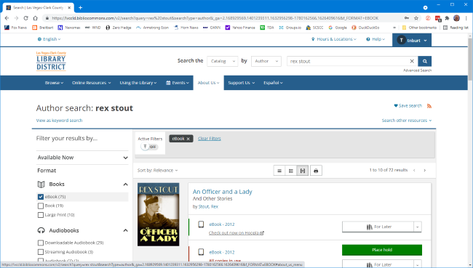

To check out a book, use the search by author, subject, or title to find the desired e-book, click the “Check Out” button, select your format (Kindle, E-Pub, OverDrive Read) and then click the Download button. For Kindle format, you get redirected to the Amazon bookstore to download the selected e-book. Amazon handles it as a sale for $0.00 that grants you 21-day reading privileges for that book. After 21 days, the book is automatically “returned,” and you can no longer read it. You get an alert email after 18 days that your “loan” is about to expire. You can also return books early. It’s polite to do that, as others are often waiting to borrow the book. The library has to pay for each lending license, so they often only license a few copies.

Hopefully, that helps you know more about e-books and how to get them. I love them because of the convenience and the ease of reading. And they take up zero space in the house.

